Directions: Sketch the graphs of the following inequalities.

y > 3x – 4 y ≤ –2x + 5 2x – y ≥ - 6

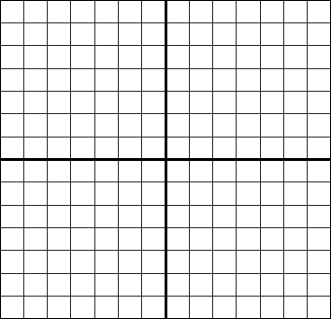

2x + 4y < 12 y – 2x ≥ - 6 y < + 3

